

**4C8 Imaging Processing Lab Assignment**

**January 27, 2020**

|  |  |
| --- | --- |
| **Contributor** | **Student Number** |
| Shida Sheng | 19303554 |

Q1 :

# 

Figure 1 Original Picture

After doing this code in Matlab

newpic = pic + 128 ;

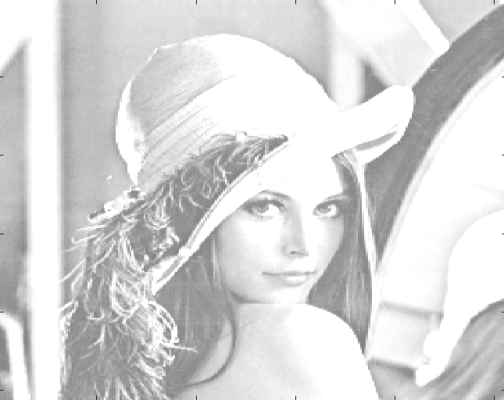

Figure 2

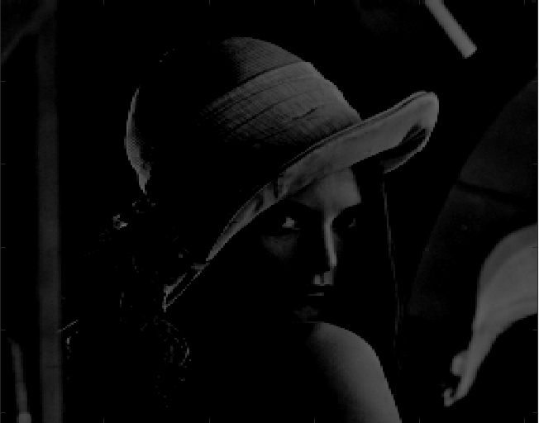

Figure 3

1. Explain what you see compared to pic. Why has much of the picture turned white?

2. Explain what you see compared to pic. Why has much of the picture turned black?

Answer: For a Gray scale Image, the pixel value is a single number that represents the brightness of the pixel. The most common pixel format is the byte image, where this number is stored as an 8-bit integer giving a range of possible values from 0 to 255. Zero is taken to be black, and 255 is taken to be white.

Q2 :

The Picture sigmedia06907.tif

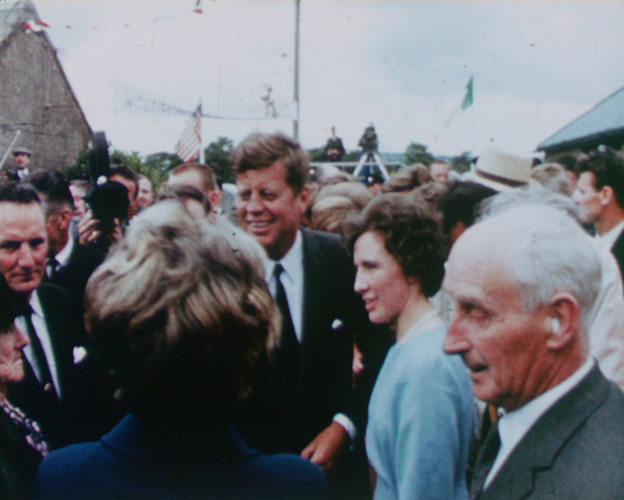

Figure 4

1. Type size(pic) in Matlab and explain the output.

Result : ans = 576 720 3

pic = rgb2gray(pic);

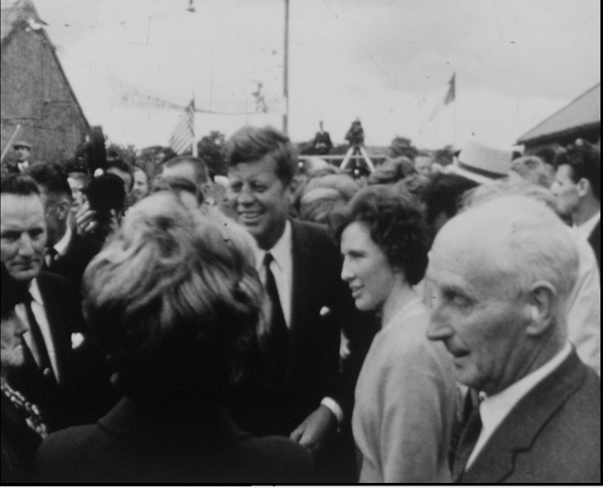

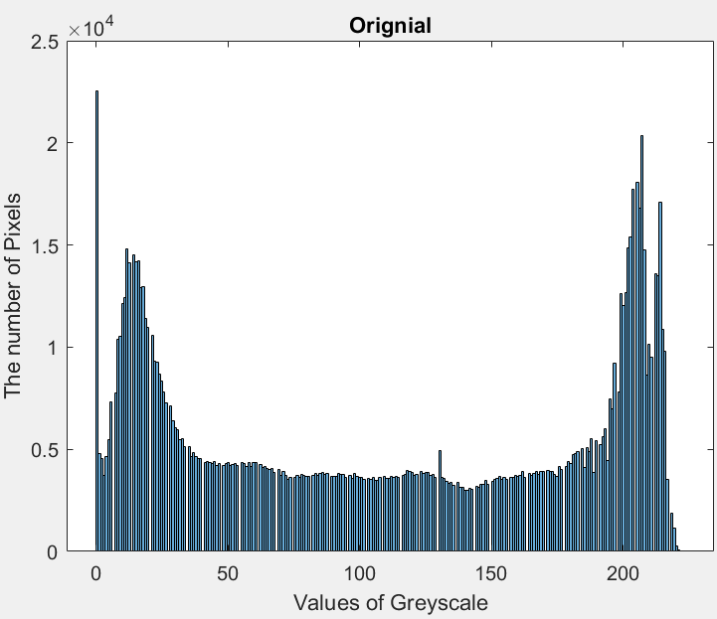

Q3:

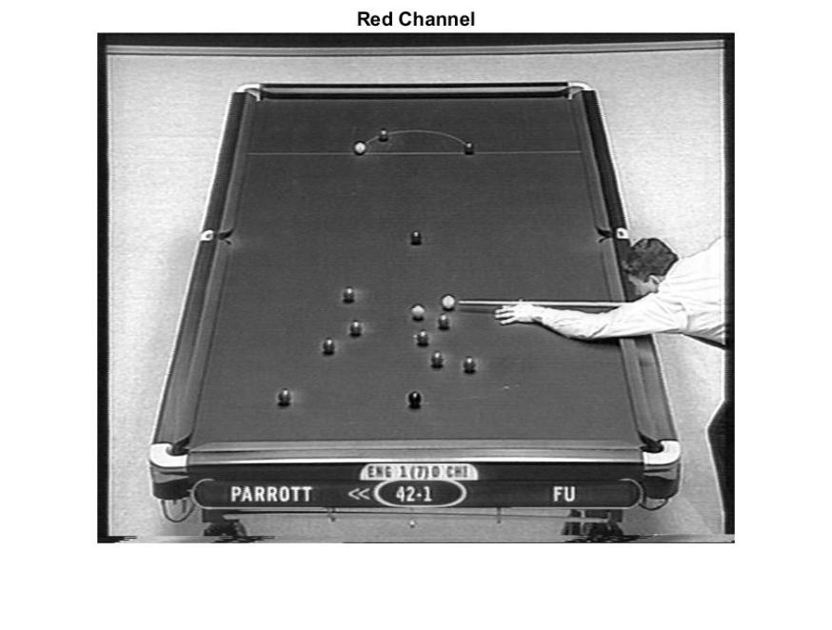

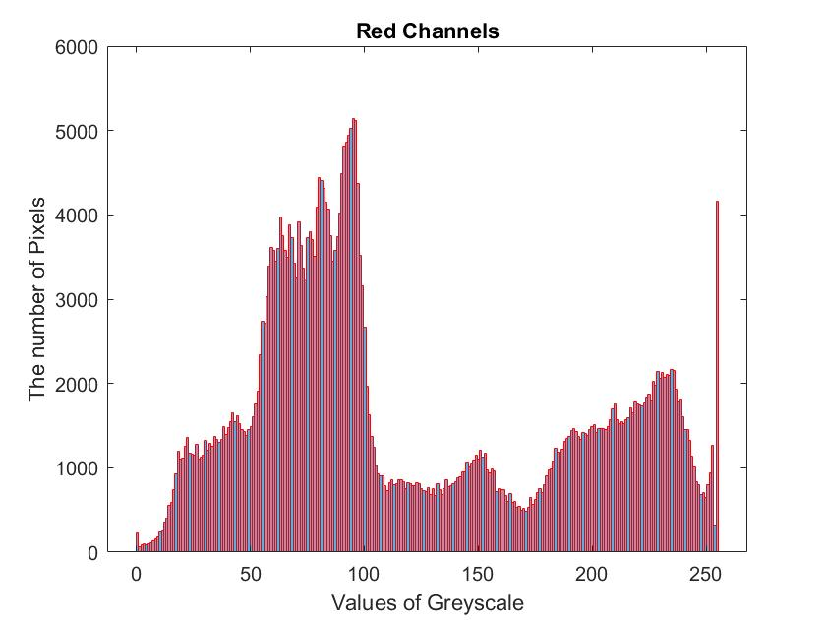

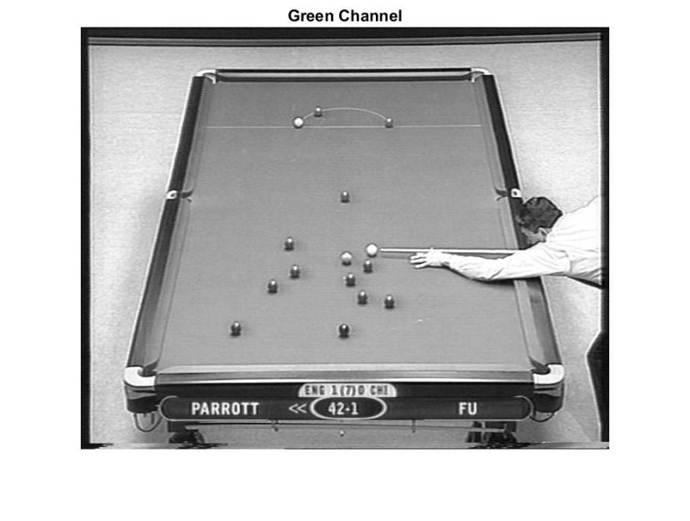

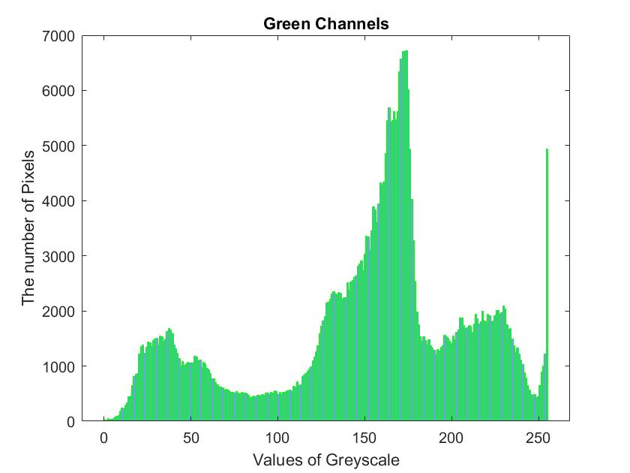

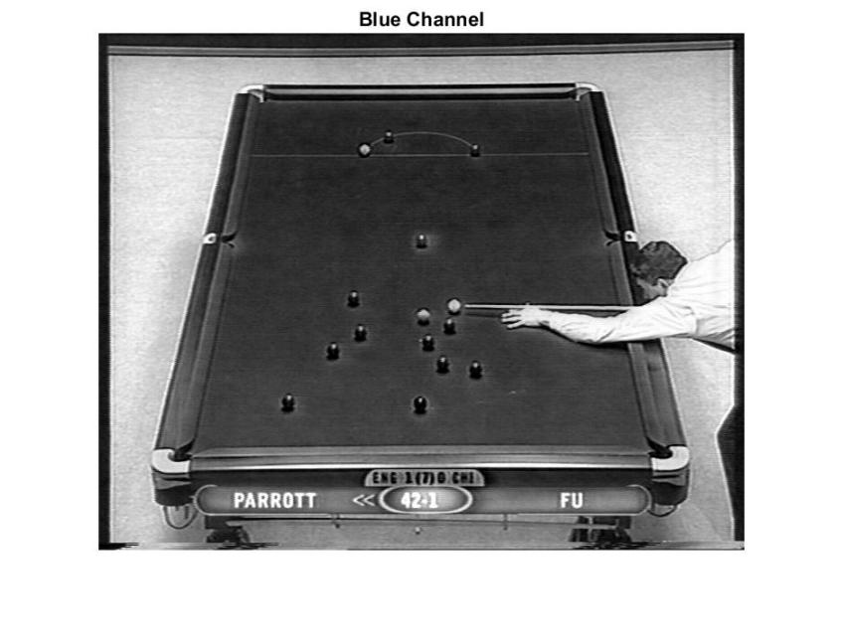

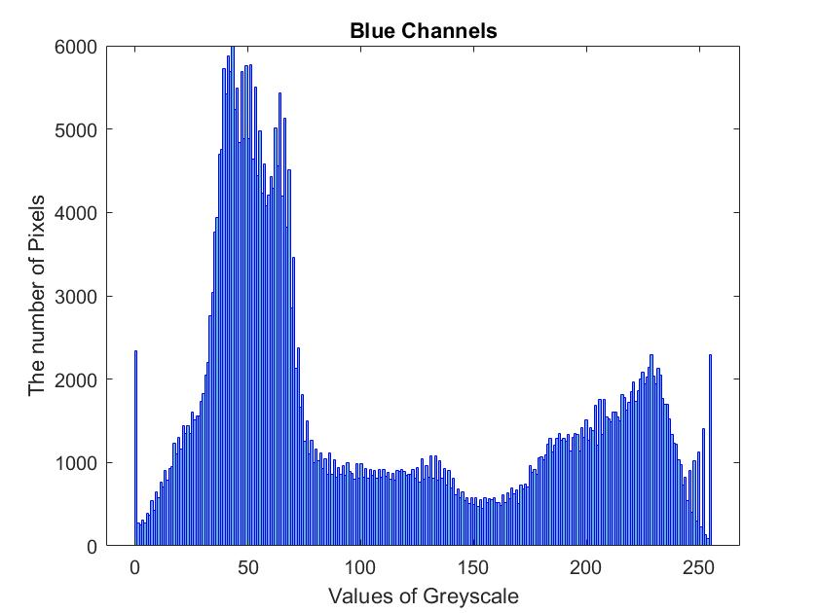

Q3 .Put images of the 3 histograms into your report. Explain how the table region of

the image manifests in the three histogram spaces.

Answer : The original pictures shows us more colour of Green. That’s why the Values of Grayscale of Green Channel are higher than the Red channel and the Blue channel. The distribution of the Value of RGB channels is based on the original image. For example,If the original have more blue colour or related to blue, the value goes high.

Q4. Include in your report, an image showing the segmentation that you achieve. De

scribe how well your *segmentation mask* matches the actual limits of the table.

Specififically mention where the algorithm works and where it does not. Write down

the values of the thresholds that you use for each channel. Explain why applying

thresholds on all 3 colour channels improves segmentation compared to performing

the segmentation on the green channel alone.

Answer4.1: In the picture of nuice, the threshold range i used is from 50 to 255. The nuice is a grey scale picture. So it just have one channel. I just need to distinguish the black and white. 50 is big enough to reduce the small noise in the picture, and it will not influence the nuice.

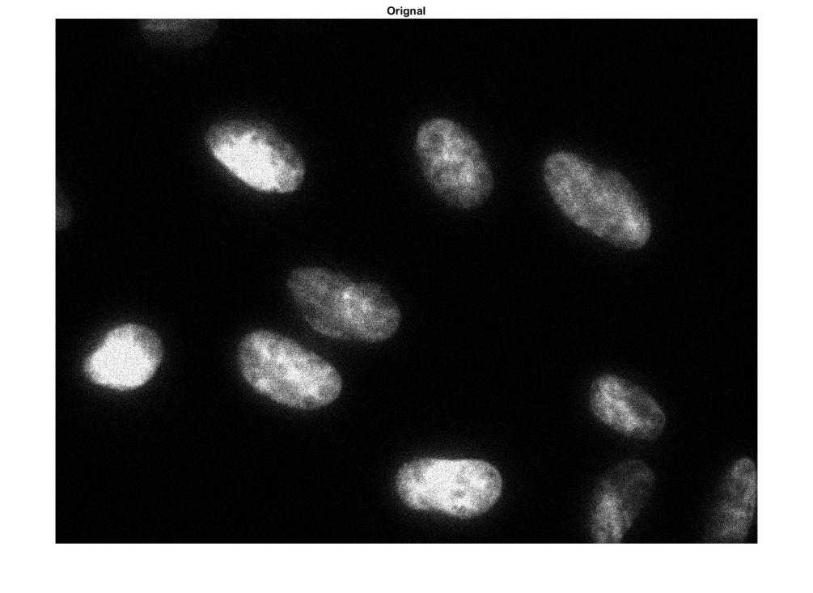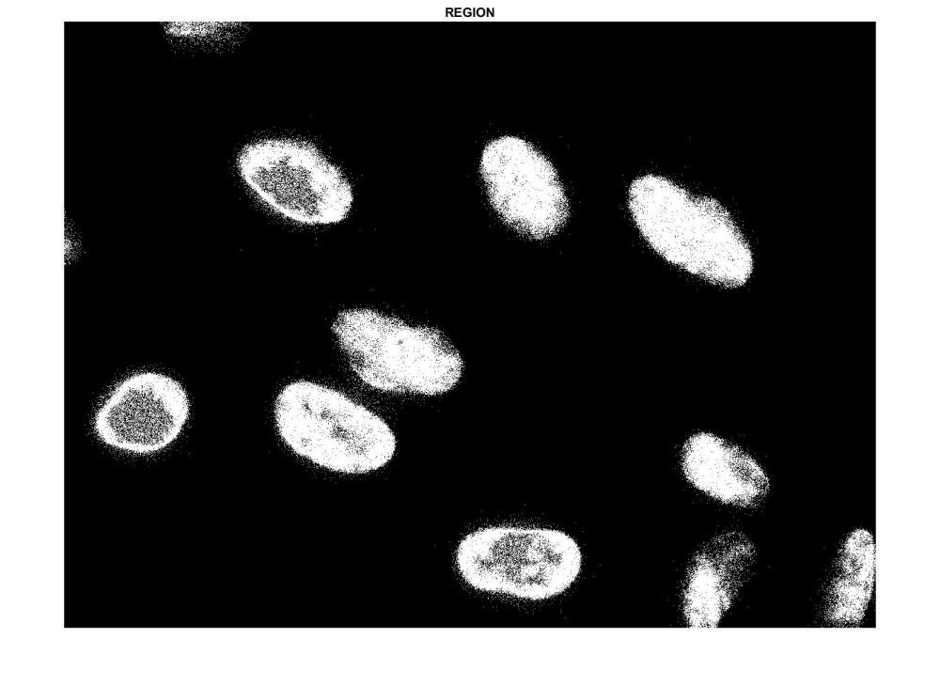

Answer4.2: In the picture of pool2, I set three pairs thresholds in R,G,B channels respectively. The colour of pool2 mostly is the green, but it still have some other colours. When I just use the G channel to do the segmentation, the result is not well.

I noticed that the white place also have a high intensive value on Green channel. That have a big influence on the picture segmentation.

When I use three pairs of thresholds in each channel to do the picture segmentation, the result is much better than the previous one.

It’s a little complicate to use three channel to do the picture segmentation, I want to try to use the YUV values to do the picture segmentation. The result is also good.

I use to different code style to get the result.

First is write a for-loop to search every pixel, Another style is to use simple matrix calculate to get the result. It is same in total.

Let’s see

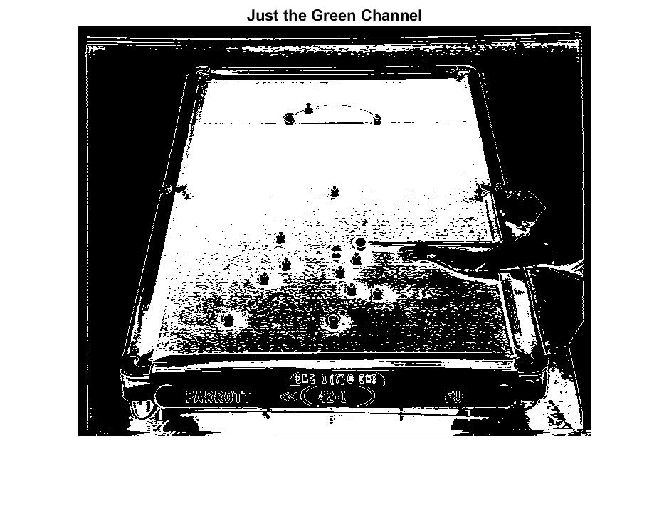

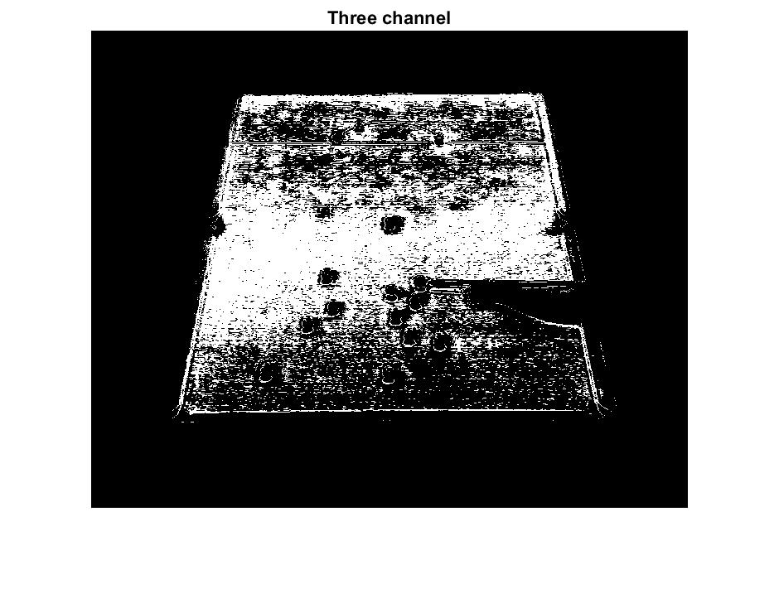

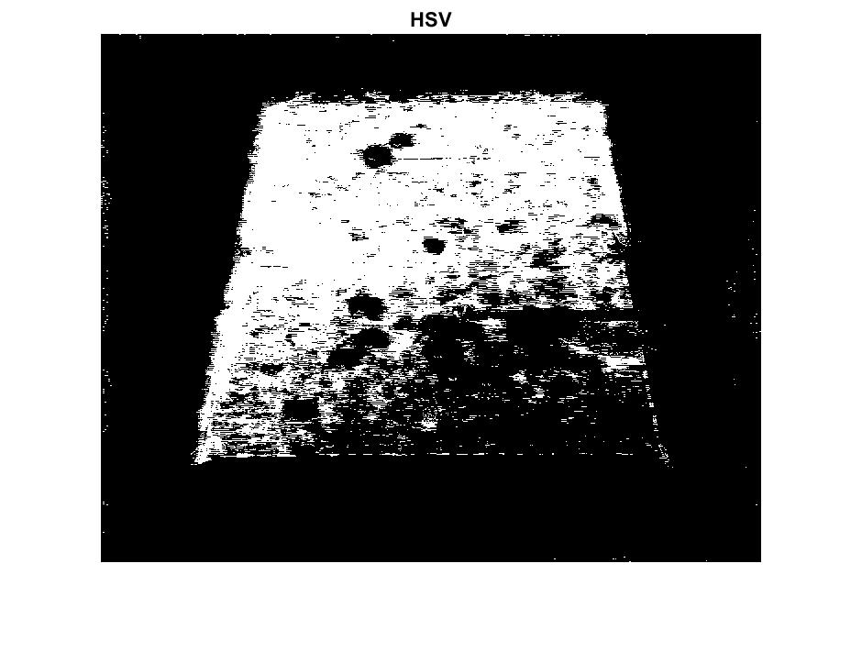

Thank you !